**AWS Task-5**

**Task Description:**

Deploy a simple web application using AWS code commit, code build and deploy & access via browser and automate via codepipeline.

**Techstacks needs to be used :**

* AWS CI-CD (CodeCommit, CodeBuild, CodeDeploy, CodePipeline).

🡺**GIT HUB**

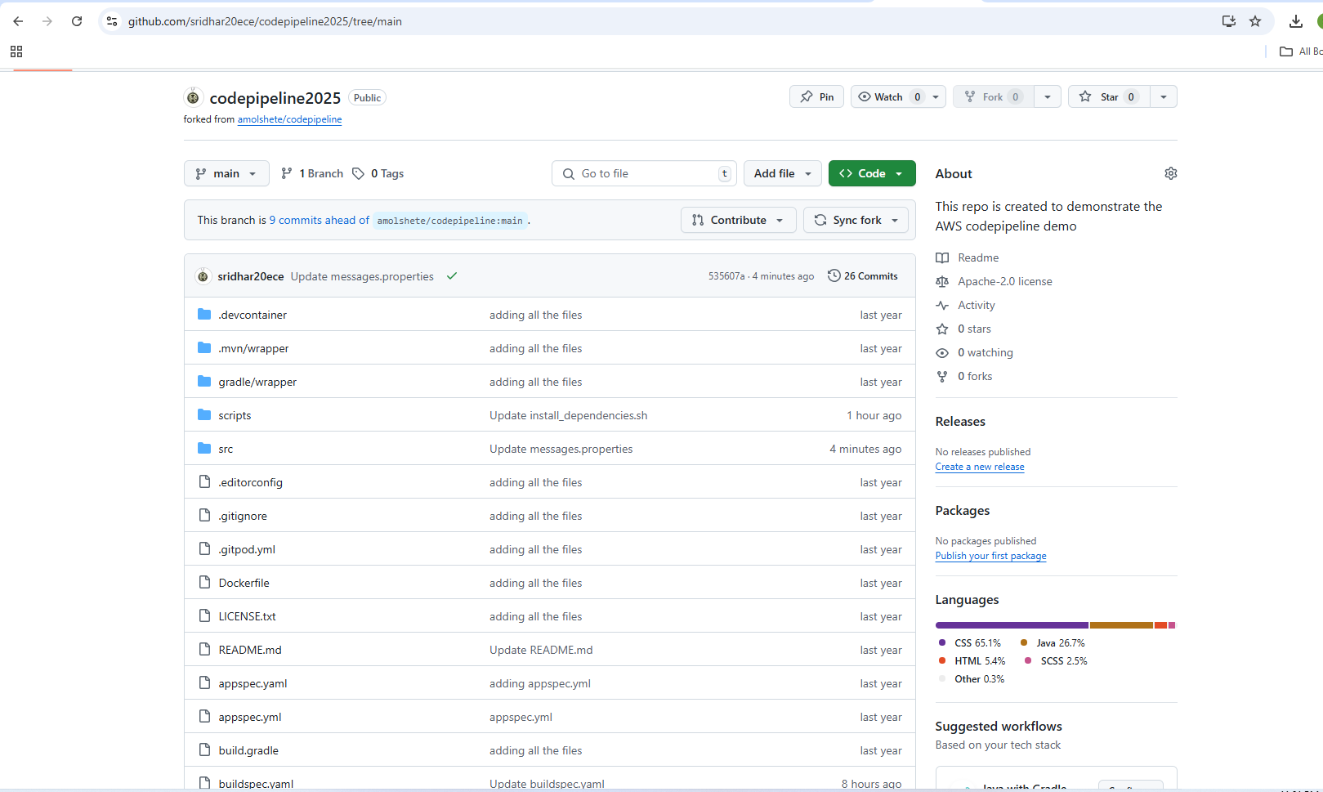

🡺**AWS CODE BUILD: -**

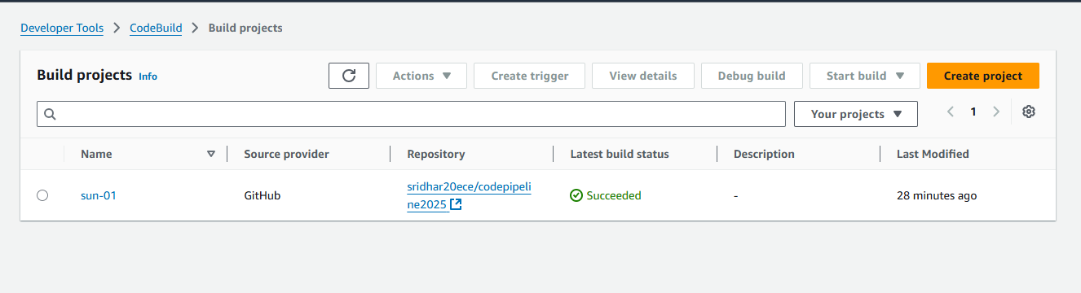

🡺**S3 ARTIFACTS: =**

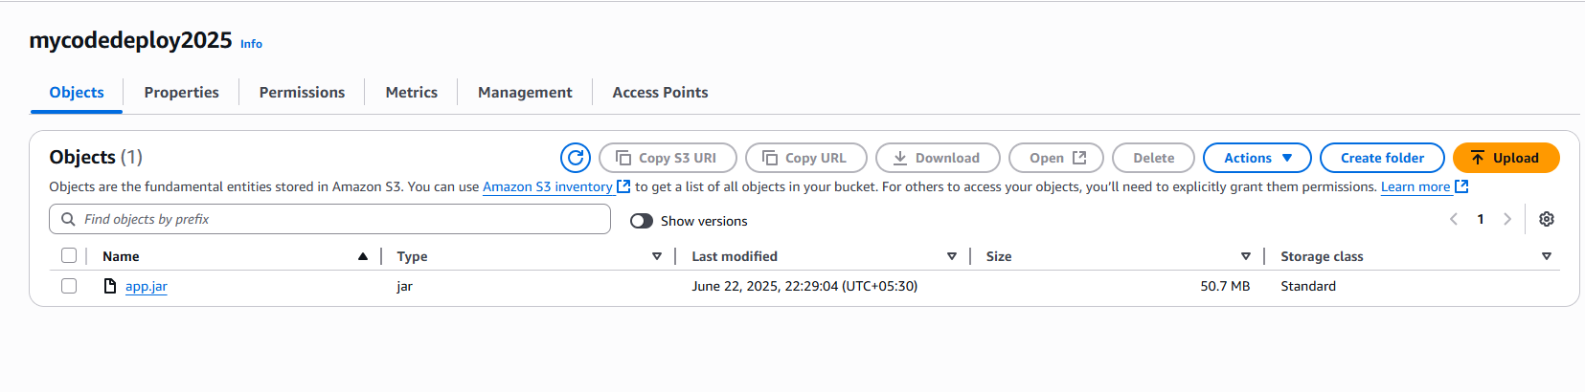  
  
  
  
🡺**AWS CODE DEPLOY: -**

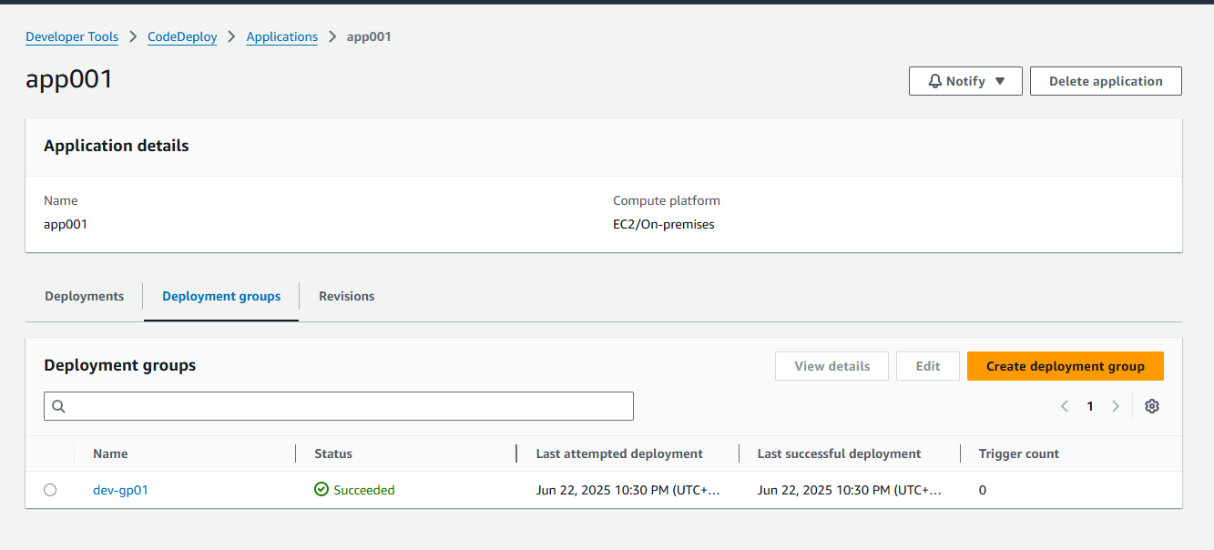

🡺 **AWS CODE PIPELINE**

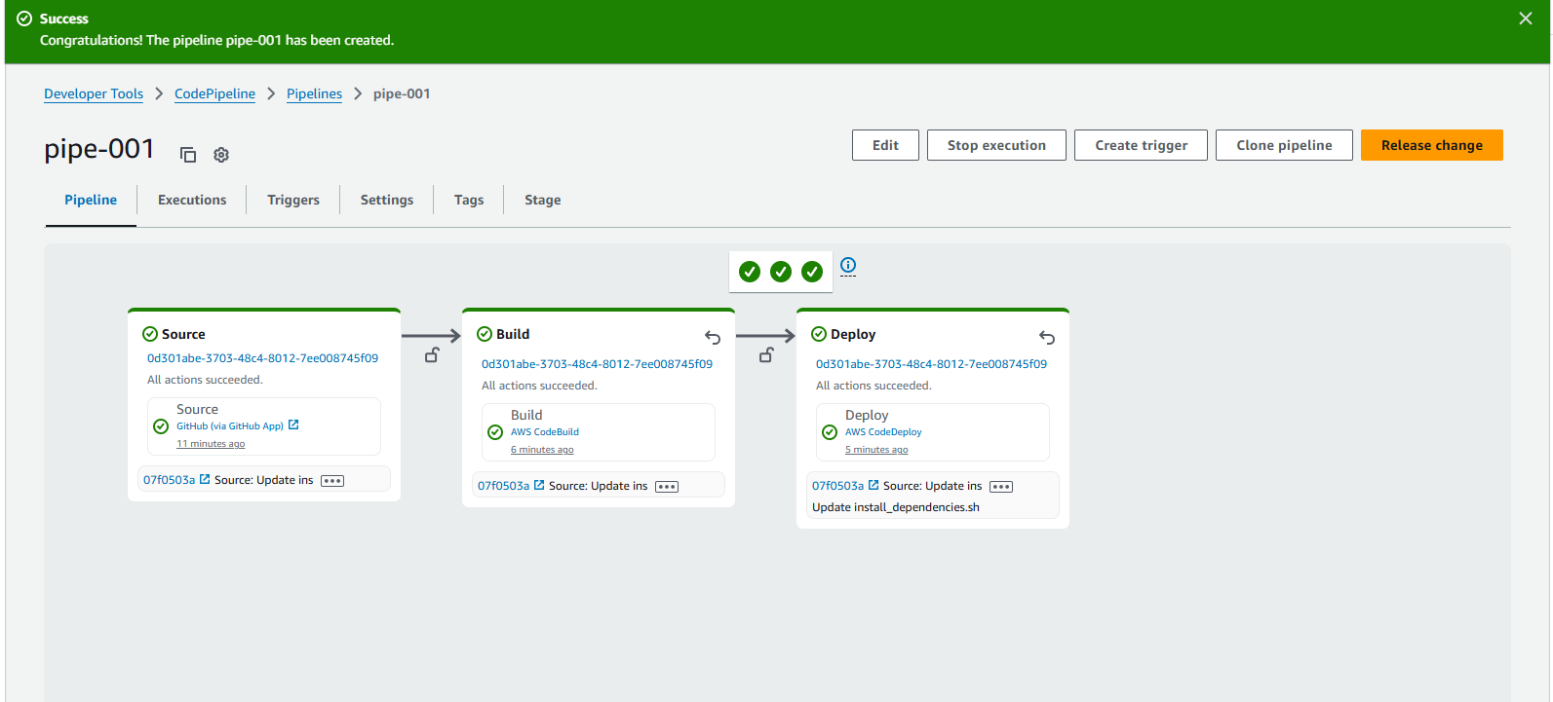

🡺After Deployment is completed, the application is accessible:-

URL:[**http://13.233.194.169:8080/**](http://13.233.194.169:8080/)

